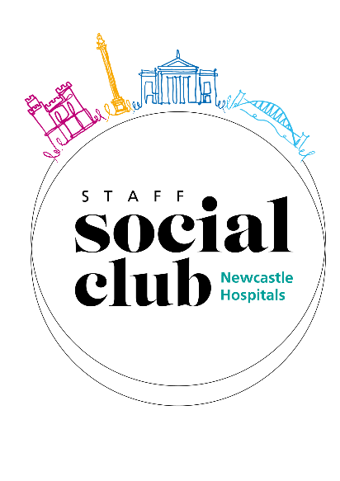
Staff Social Club Event Application Form
AF
Event | Date
Taster Session for 4 @ Newcastle Climbing Centre | Valid: 1st July 2025 – 1st July 2026
Please note: This application should only be used if you are applying from home, if you work on the Staff Bank or are not directly paid via NUTH and pay for your SSC membership via direct debit. This form should be returned to Staff Social Club at nuth.staffsocialclub@nhs.net and should be sent via your personal email address or if you are applying on someone else’s behalf we will need a hand written signature and this must be sent via post to Staff Social Club, Regent Point, Level 1 Gosforth, NE3 3HD
If you work on the Staff Bank or are not directly paid via NUTH please tick the box to the right ☐

Payroll Number | Last Name | First Name
Contact Number | Email Address | Department & Site

Detail the number of tickets you would like to request in the table below:
Ticket Type | Discount Given | Price  Each | Quantity Allowed | Quantity Requested
SSC Discounted Ticket | 50% Off | £20.25 | 1
Additional Discounted Ticket | 10% Off | £36.45 | 2
Cost Price Ticket | 0% Off | £40.50 | 10
Total number of tickets/places requested
Total cost to be deducted from your salary

These will be physical vouchers. Please select how you would like to collect your vouchers below:
Regent Point HR Reception
Newcastle Climbing Centre
Post Home (£3.20)

Declaration
By signing the below, I am:
- Confirming that I am the applicant.
- Agreeing to the amount above being deducted from my salary.
- Confirming that I am a subscribed member of the Staff Social Club.
- Agreeing to the terms and conditions set out overleaf.

Signature |  | Date
If you are applying from home and sending the form via email you can type your signature. You only need to send a wet signature when sending in the post or asking a colleague to send on your behalf.
Please ensure all sections of the form are completed before returning to SSC or your application may not be processed.

Staff Social Club
The Newcastle upon Tyne Hospitals NHS Foundation Trust
1st Floor, Regent Point
Regent Farm Road, Gosforth, Newcastle upon Tyne
NE3 3HD
(0191 28) 24047
nuth.staffsocialclub@nhs.net
https://staffsocial.newcastle-hospitals.nhs.uk/

Please see below the terms and conditions of your membership and some of our most frequently asked questions. Please note that all rules can be found in our operational policy on the committee page of our website. Click here to view the operational policy

General Information
- It is your responsibility to ensure that the correct deductions are taken from your salary. The payments detailed on the summary page and in your booking confirmation email are taken once your application is returned and accepted; normally this will be no more than one month later.
- If the deduction from your salary is different from the value detailed on the summary page and in your booking confirmation email, you must notify the SSC via email (nuth.staffsocialclub@nhs.net) immediately.
- If the deduction was incorrect, a correction will be made as soon as possible.
- It is at the discretion of the SSC Committee to permit payment over more than one month - this will only be available on pre agreed events and will be clearly advertised.
- Your booking will not be accepted until the SSC have received your application with all required fields complete.
- Your booking will not have gained tickets/places for the event you have applied for until you have received a confirmation email as to whether you have been successful or not.
- If the event requires a ticket/voucher, you will be notified on your confirmation email when you will receive your ticket/voucher by. The time it takes for tickets to be sent to you may vary and this is subject to change, but members will be notified of any changes as soon as possible.
- Tickets are expected to be used by SSC Members for their own personal use.
- Under no circumstances can a member apply for an event on someone else’s behalf. You cannot send an electronically filled in form for one of your friends or colleagues. If someone wants you to send a form via email on their behalf, they will need to fill in the form via hand, sign it and then you can send a scanned copy from your email.
- On certain events it may be necessary to impose an age limit. This will be clearly advertised.
- If you are sending an application through the post, it must be hand signed.
- You can only send an application via email if you are sending from your personal email address that is registered on your SSC membership prior to booking. Home applications sent from your NHS email cannot be processed.
- You will find out whether you were successful or not within 5 working days from the date of your application.
- All tickets are allocated on a first come, first served basis. Tickets cannot be held or booked prior to the release date.
- Please note that you must not share your username and password for the computer to allow people to apply on your behalf as this breaches the Trust IT Security policy and could result in formal action being taken. If you are sending a postal application on behalf of another member, please remember that they must have filled it in and signed it themselves. You must not sign their signature as this would be considered fraudulent.
- Insurance is not provided with any of the SSC events or trips. We recommend that all members seek and purchase their own personal insurance to cover them when attending our events. All suppliers carry their own public liability insurance and risk assessments will be carried out by either the supplier or Staff Social Club, depending on which is appropriate.
Group Bookings
- If you have booked tickets as part of a group, we will always endeavour to seat you together to the best of our ability. If this is not possible because of the seats we are allocated by the Venue, we reserve the right to split large groups and will contact you if this is the case.
- It is your responsibility to clearly state on the booking form if you wish to be seated with another member(s). Failure to do so could result in you not being seated with your group.
Ticket/voucher Collection
- If you are successful in gaining tickets/vouchers, please make sure to save your confirmation email as this includes details of when you should receive your e-tickets/vouchers.
- Please note that it is members responsibility to ensure you have received your e-ticket/voucher prior to the event. If you have not received your ticket/voucher, please inform us via email (nuth.staffsocialclub@nhs.net) as soon as possible. Please note, if we are informed too close to the event/start date we may be unable to resolve this.
- Please always make sure all information on your tickets/vouchers is correct and as expected. please inform us via email (nuth.staffsocialclub@nhs.net) as soon as possible. Please note, if we are informed too close to the event/start date we may be unable to resolve this.
- For some events where tickets/vouchers are purchased in bulk, the supplier may require a name for the booking, as a result some tickets/vouchers may have either the name Katie Firth or Sarah Legender (SSC team) listed on the tickets. Please note this will not impact your use of the tickets. If your ticket/voucher has another name on the ticket that is not listed above, please inform us as soon as possible.
- Please ensure all terms and conditions of the e-ticket/voucher are read thoroughly prior to the event to avoid any confusion over redemption. (if printing is required this would be the members responsibility and this will be stated clearly when booking).
- E-tickets/vouchers will be sent out to members work email address and personal email address if noted on your booking.
- Tickets/vouchers are now all digital from the SSC however, on the rare occasion physical tickets/vouchers are required details will be outlined at point of booking on how to collect your tickets/vouchers.
Cancellation Policy
- If you can no longer attend an event, in the first instance, please contact the SSC. If it is more than 28 days to the event/voucher start date, we will try and reallocate your ticket and if successful we will provide you with a full refund. If it is less than 28 days to the event, we may not be able to reallocate your ticket/voucher and you will be responsible for the cost of this. However, if you wish to resell your ticket privately you must seek permission from the SSC. Therefore, please contact us in the first instance. If we grant permission for you to resell privately you must not make a profit and can only sell for the price for which you purchased them for.
- The SSC has no obligation to reallocate your ticket(s)/place(s).
- The refunds will be made to your salary; normally this will be no more than one month later, but this may vary.

Staff Social Club Membership: Terms and Conditions

