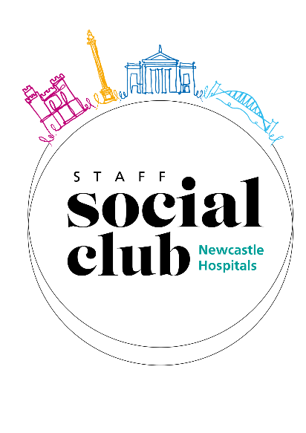
Staff Social Club Event Application Form
Event: Scarborough
Date: Saturday 17th August 2024
Please note: This application should only be used if you are applying from home, if you work on the Staff Bank or are not directly paid via NUTH and pay for your SSC membership via direct debit. This form should be returned to Staff Social Club at nuth.staffsocialclub@nhs.net and should be sent via your personal email address or if you are applying on someone else’s behalf we will need a hand written signature and this must be sent via post to Staff Social Club, Regent Point, Level 1 Gosforth, NE3 3HD
If you work on the Staff Bank or are not directly paid via NUTH please tick the box to the right ☐

Payroll Number | Last Name | First Name
Contact Number | Email Address | Department & Site

Detail the number of tickets you would like to request in the table below:
Ticket Type | Discount Given | Price  Each | Quantity Allowed | Quantity Requested
SSC Discounted Ticket | 50% Off | £6.85 | 1
Additional Discounted Ticket | 10% Off | £12.33 | 2
Cost Price Ticket | 0% Off | £13.69 | 10
Total number of tickets/places requested
Total cost to be deducted from your salary

Please select your coach collection point below
RVI Collection Point | Freeman Collection Point
☐ | ☐
There will be 2 coaches for this event. If you are travelling with another SSC member, please note their name and payroll number to the left so we can make sure you are allocated the same coach.

Declaration
By signing the below, I am:
- Confirming that I am the applicant.
- Agreeing to the amount above being deducted from my salary.
- Confirming that I am a subscribed member of the Staff Social Club.
- Agreeing to the terms and conditions set out overleaf.

Signature |  | Date

If you are applying from home and sending the form via email you can type your signature. You only need to send a wet signature when sending in the post or asking a colleague to send on your behalf.

Staff Social Club
The Newcastle upon Tyne Hospitals NHS Foundation Trust
1st Floor, Regent Point
Regent Farm Road, Gosforth, Newcastle upon Tyne
NE3 3HD
(0191 28) 24047
nuth.staffsocialclub@nhs.net
www.flourishnewcastlehospitals.co.uk/staff-social-club
Staff Social Club Membership: Terms and Conditions

Please see below the terms and conditions of your membership and some of our most frequently asked questions. Please note that all of the rules can be found in our operational policy on the committee page of our website. Click here to view the operational policy

General Information
- It is your responsibility to ensure that the correct deductions are taken from your salary. The payments detailed on the summary page and in your booking confirmation email are taken once your application is returned and accepted; normally this will be no more than one month later.
- If the deduction from your salary is different from the value detailed on the summary page and in your booking confirmation email, you must notify the SSC via email immediately.
- If the deduction was incorrect, a correction will be made as soon as possible.
- It is at the discretion of the SSC Committee to permit payment over more than one month - this will only be available on pre agreed events and will be clearly advertised.
- Your booking will not be accepted until the SSC have received your application with all required fields complete.
- Your booking will not have gained tickets/places for the event you have applied for until you have received a confirmation email as to whether you have been successful or not.
- If the event requires a ticket, you will be notified on your confirmation email when and where you will be able to collect this from. The time it takes for collection to be ready may vary.
- Tickets are expected to be used by SSC Members for their own personal use.
- Under no circumstances can a member apply for an event on someone else’s behalf. You cannot send an electronically filled in form for one of your friends or colleagues. If someone wants you to send a form via email on their behalf, they will need to fill in the form via hand, sign it and then you can send a scanned copy from your email.
- All minors must be accompanied by a fee paying adult.
- On certain events it may be necessary impose an age limit. This will be clearly advertised.
- If you are sending an application through the post, it must be hand signed.
- You can only send an application via email if you are sending from either your work email address or home email address as long as the Staff Social Club have been notified of this via your work email address prior to the application being made.
- You will find out whether you were successful or not within 5 office working days from the date of your application.
- All tickets are allocated on a first come, first served basis. Tickets cannot be held or booked prior to the release date.
- Please note that you must not share your username and password for the computer to allow people to apply on your behalf as this breaches the Trust IT Security policy, and could result in formal action being taken. If you are sending a postal application on behalf of another member, please remember that they must have filled it in and signed it themselves. You must not sign their signature as this would be considered to be fraudulent.
- Insurance is not provided with any of the SSC events or trips. We recommend that all members seek and purchase their own personal insurance to cover them when attending our events. All suppliers carry their own public liability insurance and risk assessments will be carried out by either the supplier or Staff Social Club, depending on which is appropriate.

Group Bookings
- If you have booked tickets as part of a group, we will always endeavour to seat you together to the best of our ability. If this is not possible because of the seats we are allocated by the Venue, we reserve the right to split large groups and will contact you if this is the case.
- It is your responsibility to clearly state on the booking form if you wish to be seated with another member(s). Failure to do so could result in you not being seated with your group.

Ticket Collections
- If you are successful in gaining tickets for an event, please keep a hold of your confirmation email as this includes details of when/where you can collect your tickets from and what days and times.
- If you are not able to collect you tickets at the specified times, a colleague can collect on your behalf as long as they have their ID with them and are willing to sign for them.
- Please note that it is your responsibility to pick up your tickets prior to the event.
- Please note that once the tickets are delivered to the site of your choice they cannot be moved to a different one.
- You can request to have your tickets posted to your home address. This costs an extra £6.20 and they are sent via recorded delivery. Please note that they are not insured and therefore, if they are lost, we are not able to replace or refund.

Cancellation Policy
- If you can no longer attend an event, in the first instance, please contact the SSC. If it is more than 28 days to the event, we will try and reallocate your ticket and if successful we will provide you with a full refund. If it is less than 28 days to the event, we will not be able to reallocate your place and you will be responsible for the cost of the ticket/event. However, if you wish to resell your ticket, privately, you must seek permission from the SSC, therefore please contact us in the first instance. If we grant permission for you to resell privately you must not make a profit and can only sell for the price for which you purchased them for. Only ticketed events can be resold privately if agreed by the Staff Social Club. No trips or non-ticketed events can be resold outside of the Staff Social Club.
- The SSC has no obligation to reallocate your ticket(s)/place(s).
- The refunds will be made to your salary; normally this will be no more than one month later.

